2’s compliment

Team  
Omar Ameen 231000958  
Youssef Ghallab 231000615  
Youssef Hassan 231001243  
kirellos Emad 231000920  
Summary  
This is a hardware, tinkercad and protous implmintation of 4 bit 2’s compliment. The output is displayed on 5 leds. Moreover, when the sign is positive the seven segment displays P, when it is negative the sign displays E.   
Truth table  
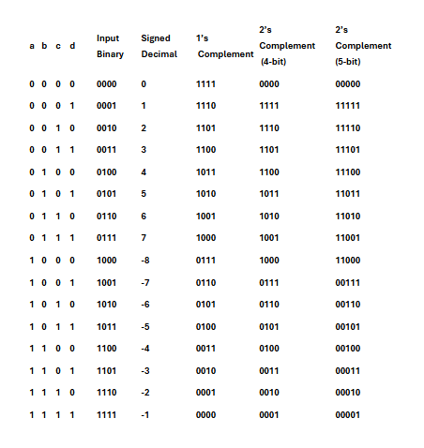  
  
General explanation   
when a 4 bit binary number is inputed this circut inverts it then it adds one. Using NOT (IC7404) AND (IC 7408) XOR (IC 7484). The output is displayed on 5 leds the fifth led indicates if the output is poitive or negative. The output is 1 (led lights up) when it is positive.   
The seven segment is common anode it is connected to show P if the fifth led is 1 and E if the fifth led is 0.  
**ِWiring clolors:**  
Orange: input/ AND to XOR   
White: vcc for switches  
red (vcc) & black(ground) connection between boards and VCC/ground for other components.  
Green: not output to and  
Yellow: AND to AND  
Purple: NOT to XOR  
brown: output from XOR to LED andoe  
note that the 7 segment used many colors generally:   
E 7segment: Orange for pin connection Yellow for common anode Blue for main power.  
P 7segment: yellow for connections purple for main power and brown for common anode.  
Data sheet for components used:  
 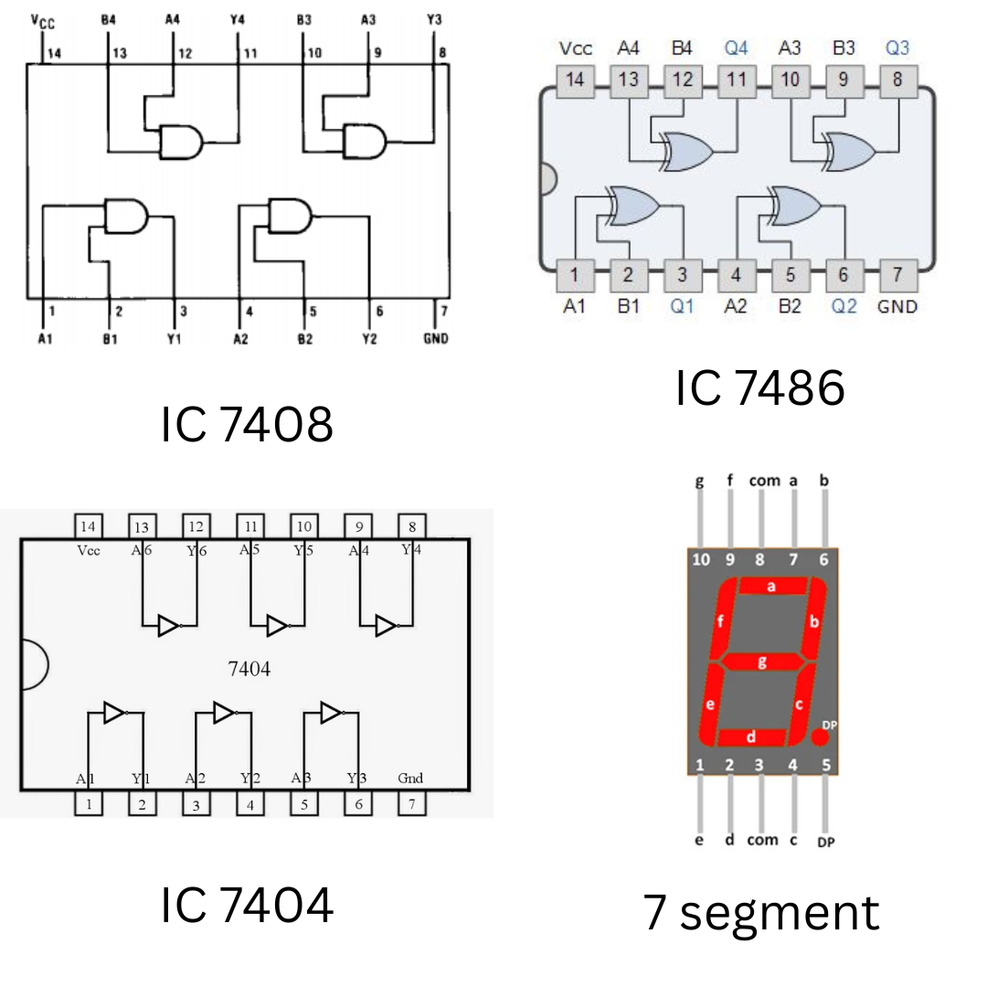  
  
Protous  
**implimentation:**   
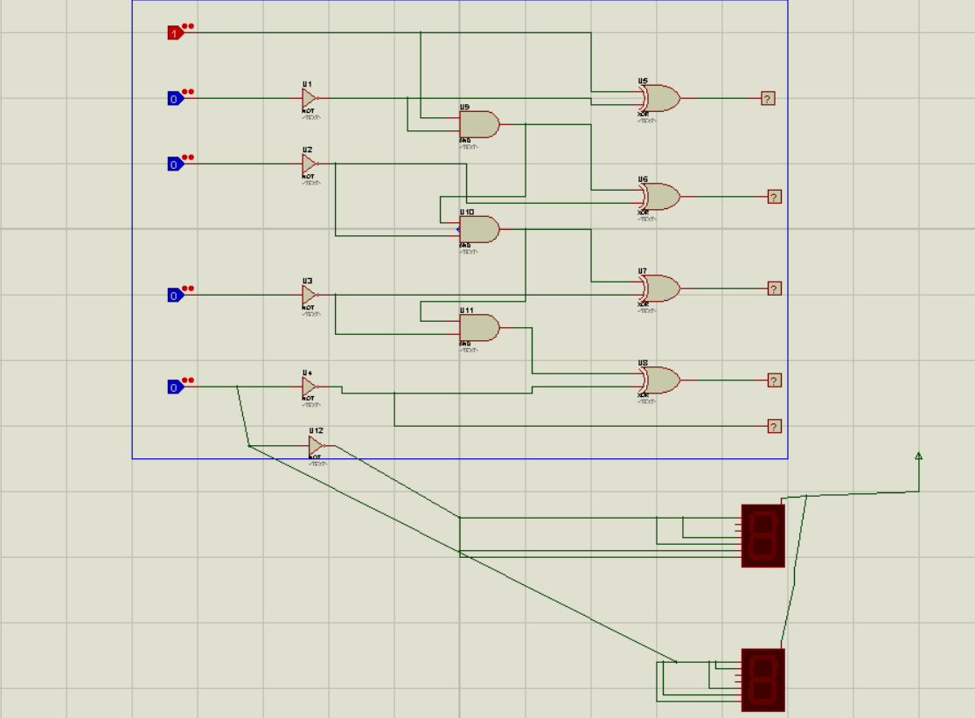  
**case 0001 (only A is 1)**  
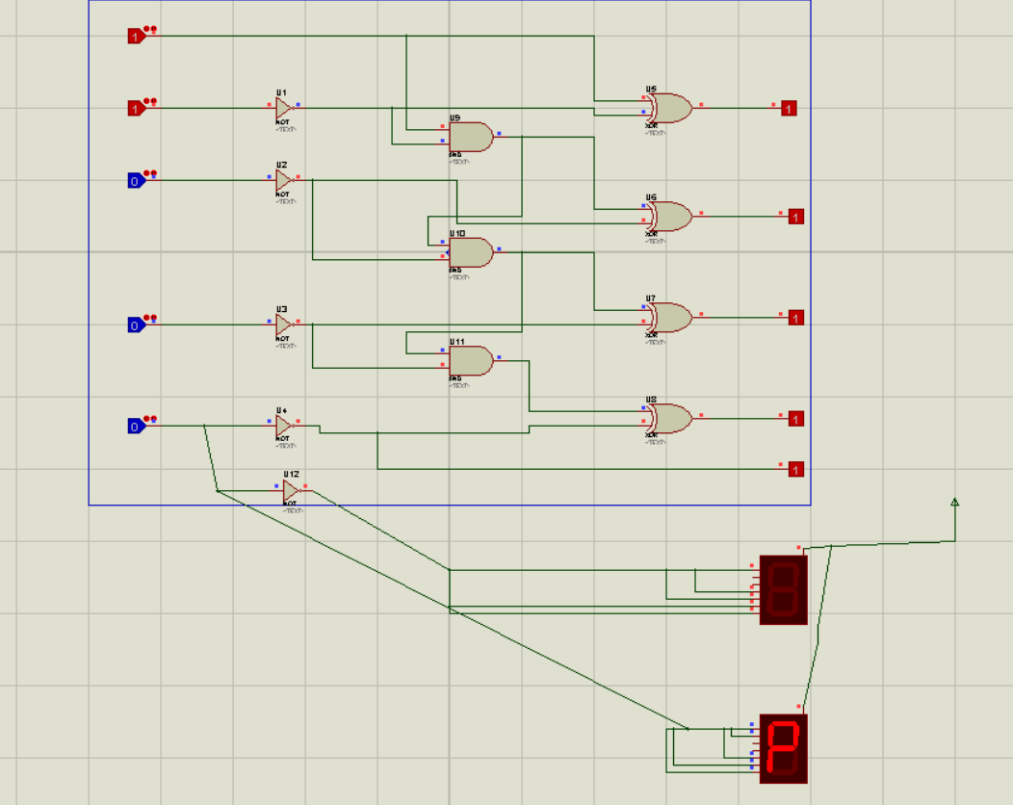

**case 1011 ( A ,B and d)**  
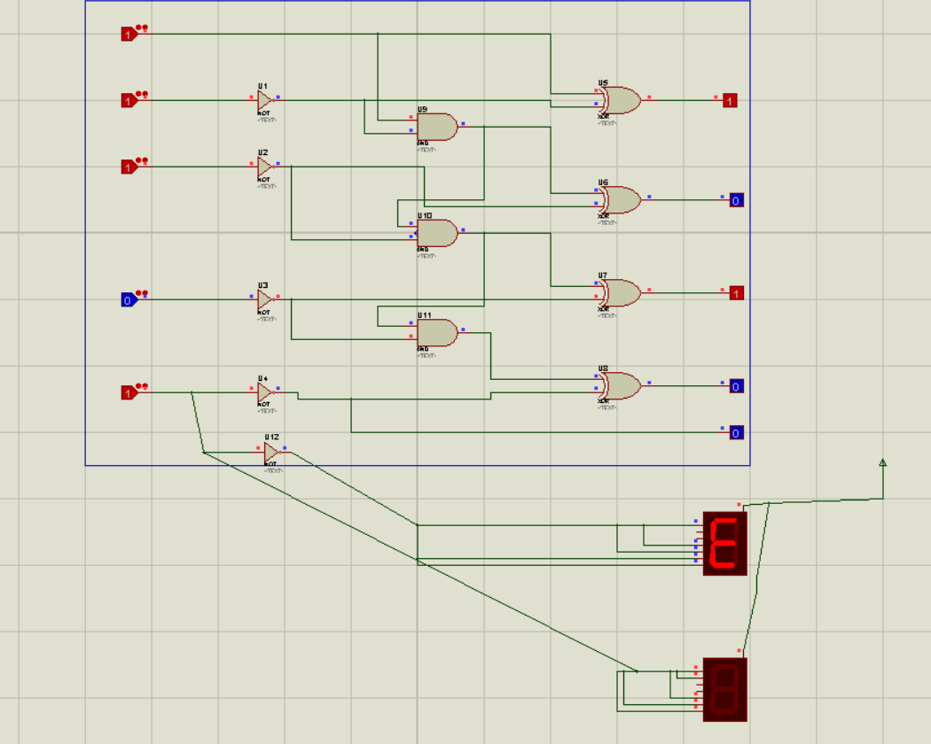

Tinkercad  
**View Link:**

<https://www.tinkercad.com/things/fIORIy8XI5R-2s-complement-final-copy?sharecode=0aLlGySN7sz6CNe0iibNCNIekGJFamaLVtuYpv6OuTI>**implimentation:**   
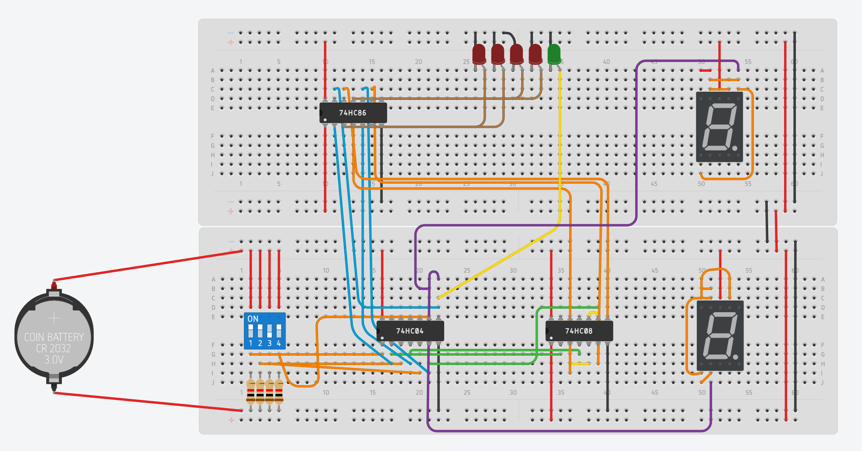  
  
**case 0001 (only A is 1)**  
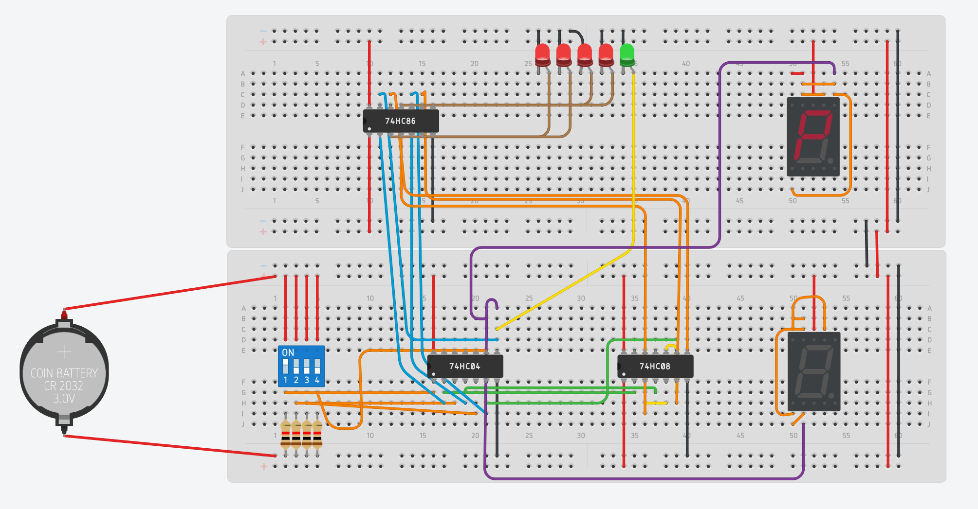

**case 1011 ( A ,B and d)**  
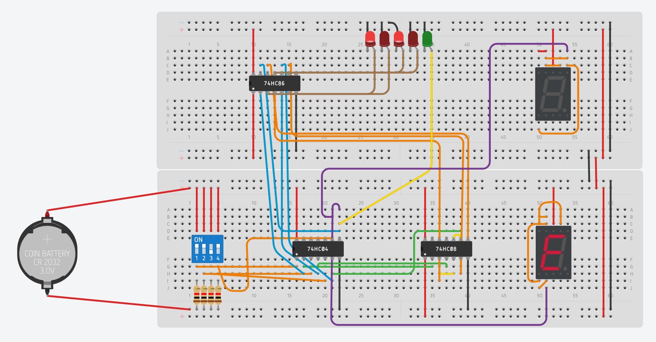  
  
Hardware implimentation  
**implimentation:**   
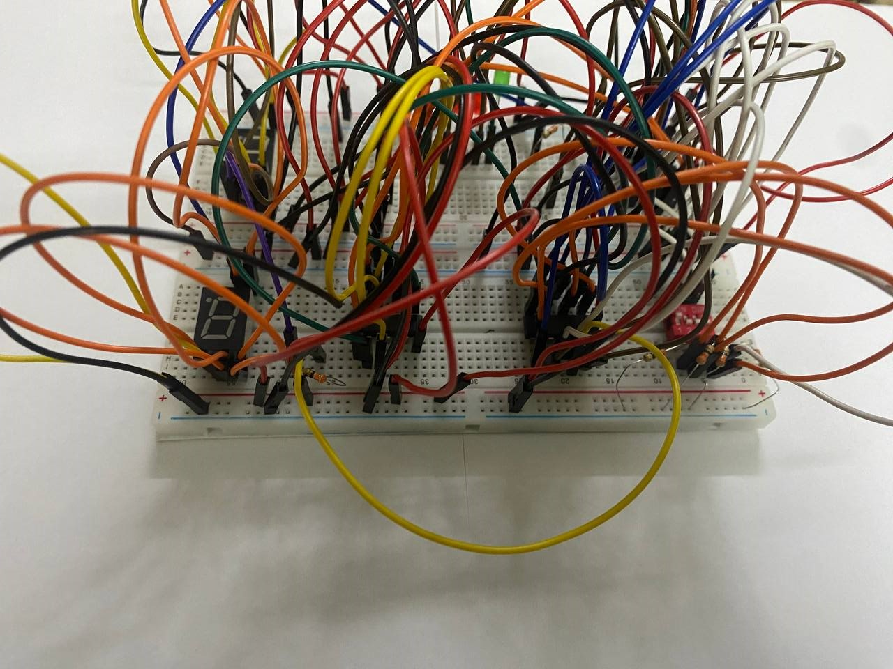  
**2**  
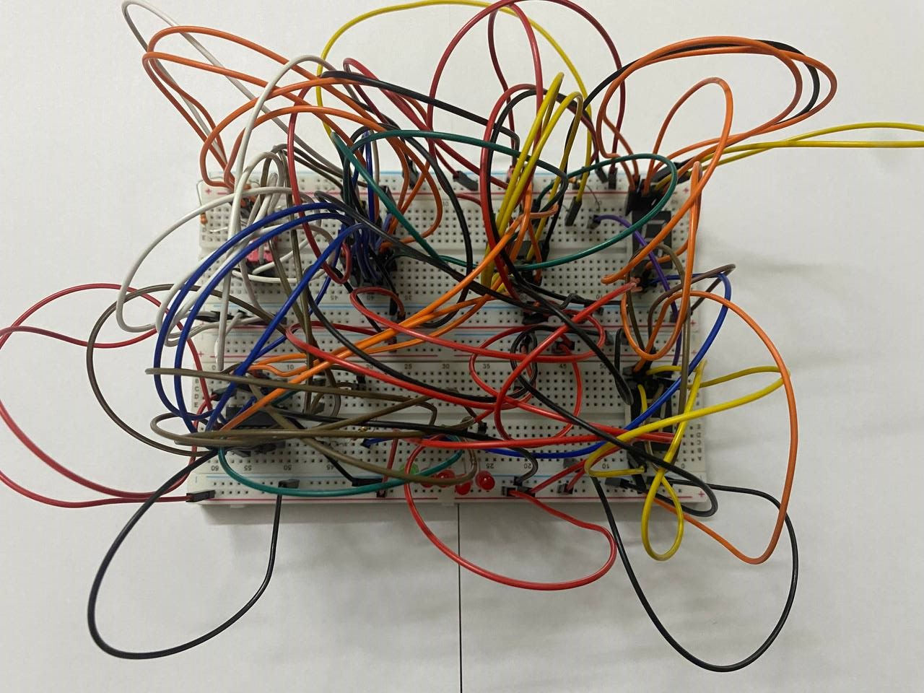  
**3**  
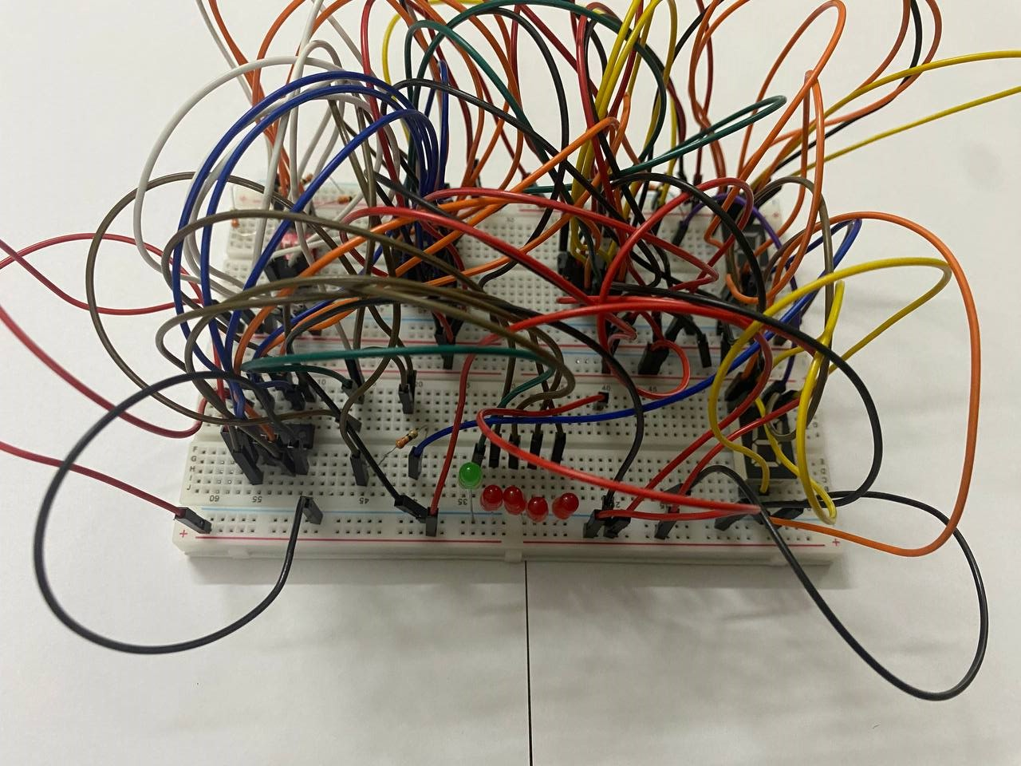  
  
  
  
  
  
  
  
**case 0001 (only A is 1)**

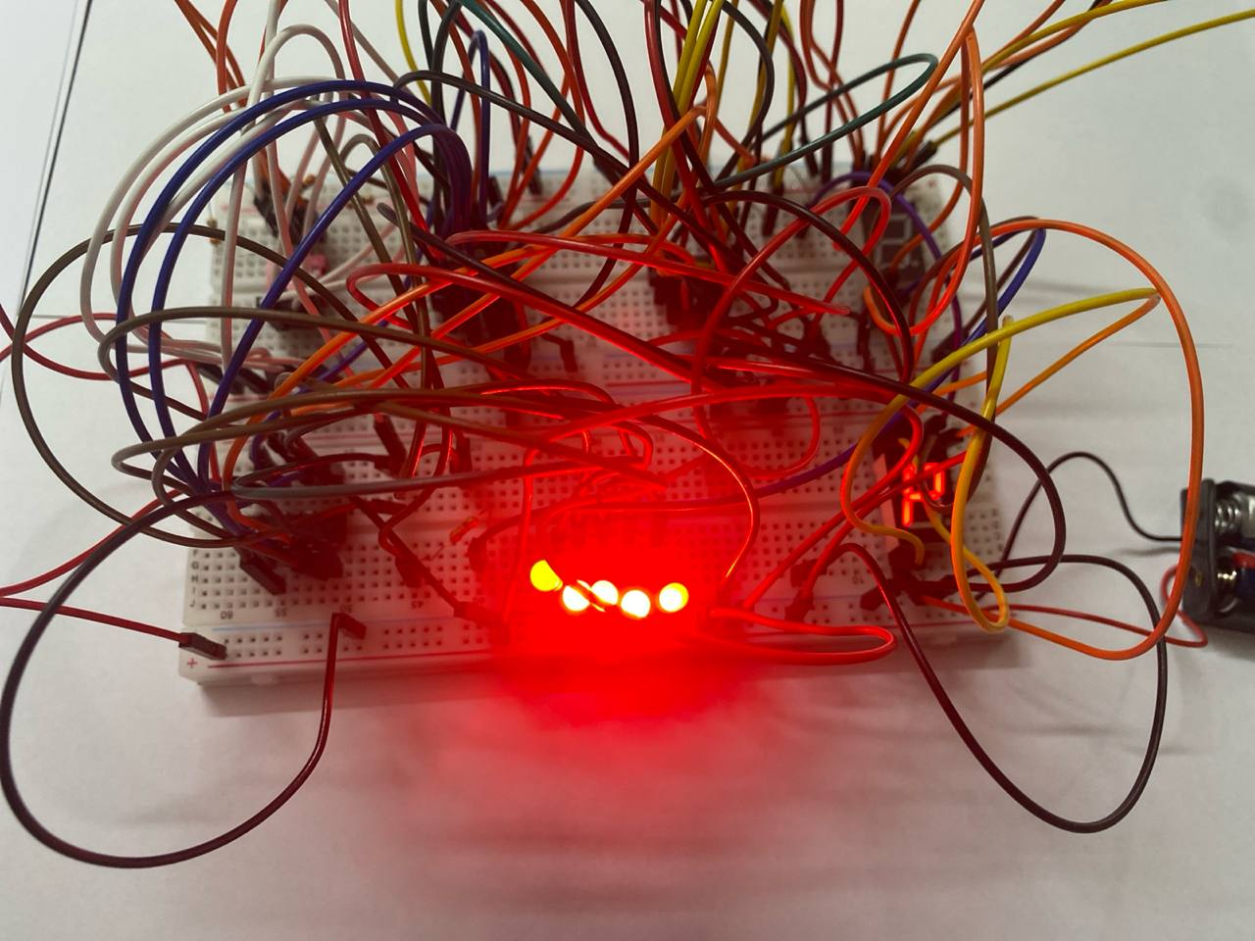

**case 1011 ( A ,B and d)**  
